Cybersecurity Analyst Internship
Task Report

[samfelix15@gmail.com]
Task No: [22 - Network Forensics]

Copyright © 2024 EncryptEdge Labs. All rights reserved
Credit: Offensive Security

Table of Contents
1.0 EncryptEdge Labs Internship Task Report 2
1.1 Introduction 3
1.2 Objective 4
1.3 Requirements 5
2.0 High-Level Summary 12
2.1 Recommendations 13
2.2 Risk exposure over time 13
3.0 Report - Methodologies 14
3.1 Information Gathering 15
4.0 Additionals Item 16
4.1 Screenshots X
1.0 EncryptEdge Labs Internship Task Report
1.1 Introduction
Network forensics is a branch of digital forensics that focuses on the investigation and analysis of network traffic and related data to detect and respond to security incidents. It involves collecting, analyzing, and preserving network traffic data to identify potential security threats, investigate incidents, and support legal proceedings.
The concept of network forensics has been around for several decades, evolving alongside the development of computer networks and cybersecurity threats. In the early days of computer networking, network security was primarily focused on preventing unauthorized access and detecting intrusions. However, as networks grew in complexity and cyber threats became more sophisticated, the need for a more comprehensive approach to network security emerged.
Network forensics emerged as a response to this need, providing a framework for investigating and analyzing network traffic to detect and respond to security incidents. Today, network forensics is a critical component of cybersecurity, enabling organizations to investigate security incidents, identify potential threats, and support legal proceedings.
The field of network forensics has evolved significantly over the years, driven by advances in technology, the increasing complexity of networks, and the growing need for incident response. Network forensics now encompasses a wide range of techniques and tools, including network traffic capture, analysis, and visualization.
Network forensics plays a vital role in supporting cybersecurity efforts, enabling organizations to:
Detect and Respond to Security Incidents: Network forensics helps organizations detect and respond to security incidents, such as unauthorized access, malware outbreaks, or data breaches.
Identify Potential Threats: Network forensics enables organizations to identify potential threats, such as suspicious network activity or anomalies in network traffic.
Support Legal Proceedings: Network forensics provides a framework for collecting, analyzing, and preserving evidence to support legal proceedings.
In this report, we will provide a comprehensive overview of network forensics, including its history, principles, tools, and best practices. We will also discuss the challenges and future directions of network forensics, highlighting its critical role in supporting cybersecurity efforts.
In the early 2000s, network forensics began to gain traction in the private sector, as organizations recognized the need for a more comprehensive approach to network security. Today, network forensics is a critical component of cybersecurity, used by organizations of all sizes to investigate security incidents and support legal proceedings.
The evolution of network forensics has been driven by advances in technology, including the development of new tools and techniques for analyzing network traffic. The increasing complexity of networks, including cloud and IoT environments, has also driven the development of new approaches to network forensics.

1.2 Objective
The primary objectives of network forensics are to:
1. Investigate Network Security Incidents: Identify and analyze network security incidents, such as unauthorized access, data breaches, or malware outbreaks.
2. Collect and Preserve Evidence: Collect and preserve network traffic data and other relevant evidence to support incident investigation and potential legal proceedings.
3. Analyze Network Traffic: Analyze network traffic data to identify patterns, anomalies, and potential security threats.
4. Determine the Root Cause: Determine the root cause of network security incidents and identify potential vulnerabilities.
5. Improve Network Security: Improve network security by implementing measures to prevent similar incidents from occurring in the future.
Network forensics involves a comprehensive approach to investigating network security incidents, including collecting and analyzing network traffic data, identifying potential security threats, and preserving evidence for potential legal proceedings.
In this report I am objected to,
Understand core digital forensics principles and best practices.
Develop skills in data collection, preservation, and analysis for forensic investigations.
Interpret forensic data to gain insights into potential security incidents.

1.3 Requirements
The requirements for network forensics include:
1. Network Traffic Capture: Capturing network traffic data using tools such as packet sniffers or network taps.
2. Data Storage: Storing network traffic data in a secure and accessible manner.
3. Analysis Tools: Utilizing analysis tools, such as protocol analyzers or intrusion detection systems, to analyze network traffic data.
4. Expertise: Having expertise in network protocols, security threats, and forensic analysis techniques.
5. Chain of Custody: Maintaining a chain of custody for evidence to ensure its integrity and admissibility in court.
Network forensics requires specialized tools, expertise, and procedures to collect, analyze, and preserve network traffic data.
Based on this report I am required to do the following,

- Submit a summary of key forensic principles, highlighting the importance of maintaining integrity and proper evidence handling procedures.
- Describe the selected tools, focusing on their unique features and their practical applications in digital forensics.
- Document your data collection methods, note any challenges faced, and include screenshots of the collection process.
- Summarize your findings, describing any significant discoveries related to the hypothetical security incident. Include screenshots where relevant.
Tools used in this tasks will include
Forensic software tools (e.g., Autopsy, FTK Imager, Sleuth Kit)
Virtual environment for safe forensic practices
Sample data for analysis

Key Forensic Principles
Network forensics involves applying key forensic principles to investigate network security incidents. These principles include:
1. Maintaining Integrity: Ensuring that evidence is collected, stored, and analyzed in a manner that maintains its integrity and admissibility in court.
2. Chain of Custody: Maintaining a chain of custody for evidence to ensure that it is handled and stored properly.
3. Preservation of Evidence :Preserving evidence in a manner that prevents tampering or alteration.
4. Documentation: Documenting all steps taken during the investigation, including evidence collection, analysis, and storage.
These principles are critical to ensuring that evidence is collected, analyzed, and preserved in a manner that supports incident investigation and potential legal proceedings.
Tools Involved in Network Forensics
Network forensics involves utilizing specialized tools to collect, analyze, and preserve network traffic data. These tools include:
Packet Sniffer: Tools that capture and analyze network traffic data, such as Wireshark or Tcpdump.
Network Taps: Devices that capture network traffic data, providing a copy of all traffic flowing through a network segment.
Intrusion Detection Systems: Systems that detect and alert on potential security threats, such as Snort or Suricata.
Forensic Analysis Tool: Tools that analyze network traffic data, such as NetworkMiner or Xplico.
These tools are used to collect, analyze, and preserve network traffic data, providing insights into potential security threats and supporting incident investigation.
Protecting Integrity
Protecting the integrity of evidence is critical in network forensics. This involves:
Secure Storage: Storing evidence in a secure manner, such as using encrypted storage devices.
Access Controls: Implementing access controls to ensure that only authorized personnel can access evidence.
Chain of Custody: Maintaining a chain of custody for evidence to ensure that it is handled and stored properly.
By protecting the integrity of evidence, organizations can ensure that it is admissible in court and supports incident investigation.
Conclusion
Network forensics is a critical component of cybersecurity that involves investigating network security incidents, collecting and preserving evidence, and analyzing network traffic data. By applying key forensic principles, utilizing specialized tools, and protecting the integrity of evidence, organizations can improve their incident response capabilities and reduce the risk of security breaches
Network Forensics Tools
Network forensics tools are specialized software and hardware solutions designed to collect, analyze, and preserve network traffic data. These tools can be categorized into several types, including:
Packet Capture Tools: Tools that capture network traffic data, such as Wireshark or Tcpdump.
Network Monitoring Tools: Tools that monitor network traffic in real-time, such as intrusion detection systems (IDS) or network performance monitoring tools.
Forensic Analysis Tools: Tools that analyze network traffic data, such as Autopsy, NetworkMiner or Xplico.
Network Forensic Platforms: Platforms that provide a comprehensive solution for network forensic analysis, such as Splunk or ELK Stack.

Autopsy: Preferred Network Forensics Tool

Autopsy is a powerful, open-source digital forensics tool used for in-depth analysis of hard drives and mobile devices. Its advantages and impact on security are significant, making it a vital tool in network forensics.
Advantages:
Comprehensive Analysis: Autopsy offers a wide range of analysis capabilities, including file system analysis, timeline analysis, keyword searching, and hash analysis.
User-Friendly Interface: Despite its advanced features, Autopsy has a user-friendly interface that makes it accessible to both beginners and experienced investigators.
Customizable: Autopsy allows users to create custom modules and ingest data from various sources, including hard drives, USB drives, memory cards, and mobile devices.
Collaboration: Autopsy's multi-user capabilities enable teams to collaborate on cases, enhancing investigation efficiency.
Impact on Security:
Digital Evidence Recovery: Autopsy helps recover deleted files, examine malware, and analyze compromised systems, making it an essential tool for incident response teams.
Forensic Analysis: Autopsy's robust reporting features generate detailed reports that can be used as evidence in court, supporting legal proceedings.
Threat Hunting: Autopsy's timeline analysis and keyword searching capabilities enable investigators to identify potential security threats and track malicious activity.
Best Practices:
Proper Case Management: Define case names and metadata, and ensure proper archiving of case-related data.
Data Source Selection: Carefully select data sources, including disk images, local drives, or folders, to ensure comprehensive analysis.
Ingest Module Configuration: Choose relevant ingest modules, such as file type identification, keyword search, and registry analysis, to extract valuable evidence.
Quality Assurance: Validate data integrity, verify analysis results, and maintain a documented chain of custody to ensure the accuracy and reliability of findings.
Use Cases:
Law Enforcement Investigations : Autopsy is used by law enforcement agencies to analyze seized digital devices for evidence.
Corporate Investigations: Autopsy helps analyze user activity and recover evidence in internal investigations.
Incident Response and Threat Hunting: Autopsy is valuable for incident response teams to analyze compromised systems, examine malware, and recover data.

Advanced Features of Autopsy
Autopsy offers several advanced features that make it a powerful tool for digital forensics and network security investigations. Some of these features include:
File System Analysis: Autopsy supports analysis of various file systems, including FAT, NTFS, Ext2, Ext3, and Ext4.
Timeline Analysis: Autopsy allows investigators to create timelines of file activity, helping to identify patterns and anomalies.
Keyword Searching: Autopsy enables investigators to search for specific keywords within files, helping to identify relevant evidence.
Hash Analysis: Autopsy can analyze hash values of files, helping to identify known malicious files or verify the integrity of files.
Benefits of Using Autopsy
The benefits of using Autopsy for digital forensics and network security investigations include:
Comprehensive Analysis: Autopsy provides a comprehensive analysis of digital evidence, helping investigators to identify relevant information.
Improved Efficiency: Autopsy's automated analysis capabilities help investigators to analyze large volumes of data quickly and efficiently.
Enhanced Accuracy: Autopsy's advanced analysis capabilities help investigators to identify patterns and anomalies that may not be visible through manual analysis.
Autopsy is a powerful tool for digital forensics and network security investigations, offering advanced analysis capabilities and improved efficiency. By following best practices and using Autopsy effectively, investigators can identify relevant evidence and build strong cases. Whether you're a seasoned investigator or just starting out, Autopsy is a valuable tool to have in your toolkit.

When to Use Network Forensics Tools
Network forensics tools are used in various scenarios, including:
Incident Response: Network forensics tools are used to investigate network security incidents, such as unauthorized access or malware outbreaks.
Threat Hunting: Network forensics tools are used to proactively hunt for potential security threats, such as suspicious network activity.
Compliance: Network forensics tools are used to support compliance with regulatory requirements, such as logging and monitoring network traffic.
By using network forensics tools, organizations can improve their incident response capabilities, detect potential security threats, and ensure compliance with regulatory requirements.
Best Practices for Network Forensics
Best practices for network forensics include:
Collecting and Preserving Evidence: Collecting and preserving network traffic data in a manner that maintains its integrity and admissibility in court.
Analyzing Network Traffic: Analyzing network traffic data to identify patterns, anomalies, and potential security threats.
Maintaining Chain of Custody: Maintaining a chain of custody for evidence to ensure that it is handled and stored properly.
Documenting Investigation: Documenting all steps taken during the investigation, including evidence collection, analysis, and storage.
By following these best practices, organizations can ensure that network forensics is conducted in a manner that supports incident investigation and potential legal proceedings
Challenges in Network Forensics
Network forensics can be challenging due to several factors, including:
Complexity of Network Traffic: Network traffic can be complex and difficult to analyze, especially in large and distributed networks.
Volume of Data: The volume of network traffic data can be overwhelming, making it challenging to identify relevant information.
Encryption: Encrypted network traffic can make it difficult to analyze and identify potential security threats.
Evasion Techniques: Attackers may use evasion techniques, such as fragmentation or encryption, to evade detection.
These challenges highlight the need for specialized tools and expertise in network forensics.
Future of Network Forensics
The future of network forensics is likely to be shaped by several factors, including:
Advances in Technology: Advances in technology, such as artificial intelligence and machine learning, are likely to improve the efficiency and effectiveness of network forensics.
Increasing Complexity of Networks: The increasing complexity of networks, including cloud and IoT environments, will require new approaches to network forensics.
Growing Need for Incident Response: The growing need for incident response will drive the development of new tools and techniques for network forensics.
As network forensics continues to evolve, it will play an increasingly important role in supporting cybersecurity and incident response efforts.
2.0 High-Level Summary
Network forensics is a critical component of cybersecurity that involves investigating network security incidents, collecting and preserving evidence, and analyzing network traffic data. It requires specialized tools, expertise, and procedures to ensure the integrity and admissibility of evidence. By leveraging network forensics, organizations can improve their incident response capabilities, reduce the risk of security breaches, and ensure compliance with regulatory requirements.
Secondly, network forensics is a critical component of cybersecurity, enabling organizations to investigate security incidents, identify potential threats, and support legal proceedings. By understanding the principles, tools, and best practices of network forensics, organizations can improve their incident response capabilities and reduce the risk of security breaches. As network forensics continues to evolve, it will play an increasingly important role in supporting cybersecurity efforts and protecting against emerging threats. ‎<This message was edited>
Network forensics involves a comprehensive approach to investigating network security incidents, including:
Network Traffic Data: Capturing network traffic data using tools such as packet sniffers or network taps.
Analyzing Network Traffic: Analyzing network traffic data to identify patterns, anomalies, and potential security threats.
Preserving Evidence: Preserving network traffic data and other relevant evidence to support incident investigation and potential legal proceedings.

2.1 Recommendations
Based on the importance of network forensics, it is recommended that organizations:
Implement Network Forensics Tools: Implement network forensics tools, such as packet sniffers or network taps, to collect and analyze network traffic data.
Develop Incident Response Plans: Develop incident response plans that include procedures for collecting and preserving evidence.
Provide Training: Provide training to personnel on network forensics and incident response procedures.
Continuously Monitor Network Traffic: Continuously monitor network traffic to identify potential security threats and improve incident response capabilities.
By implementing these recommendations, organizations can improve their network security posture and reduce the risk of security breaches.

2.2 Risk Exposure over Time
Network security incidents can have significant consequences, including:
Data Breaches Unauthorized access to sensitive data can result in data breaches, which can have serious consequences for organizations.
System Downtime: Network security incidents can result in system downtime, which can impact business operations and revenue.
Reputational Damage: Network security incidents can damage an organization's reputation, leading to loss of customer trust and loyalty.
Network forensics can help organizations reduce the risk of security breaches and improve their incident response capabilities.

3.0 Methodologies
The methodology for network forensics involves:
1. Preparation: Preparing for network forensic analysis by ensuring that necessary tools and expertise are available.
2. Data Collection: Collecting network traffic data using tools such as packet sniffers or network taps.
3. Data Analysis: Analyzing network traffic data to identify patterns, anomalies, and potential security threats.
4. Evidence Preservation: Preserving network traffic data and other relevant evidence to support incident investigation and potential legal proceedings.
5. Reporting: Reporting on the findings of the network forensic analysis, including recommendations for improving network security.
Network forensics requires a structured methodology to ensure that evidence is collected, analyzed, and preserved in a manner that supports incident investigation and potential legal proceedings.

3.1 Information Gathering
Information gathering in network forensics involves collecting network traffic data and other relevant evidence. This can include:
Network Traffic Capture: Capturing network traffic data using tools such as packet sniffers or network taps.
Log Analysis: Analyzing log data from network devices, such as firewalls or intrusion detection systems.
Network Device Configuration: Collecting configuration data from network devices, such as routers or switches.
Information gathering is a critical component of network forensics, as it provides the evidence needed to support incident investigation and potential legal proceeding.
4.0 Additional Items
4.1 Screenshots
This section will include lab completed screenshots on the Tryhackme platform. Which includes
- Intro to Digital Forensics
- Windows Forensics
- Digital Forensics Case

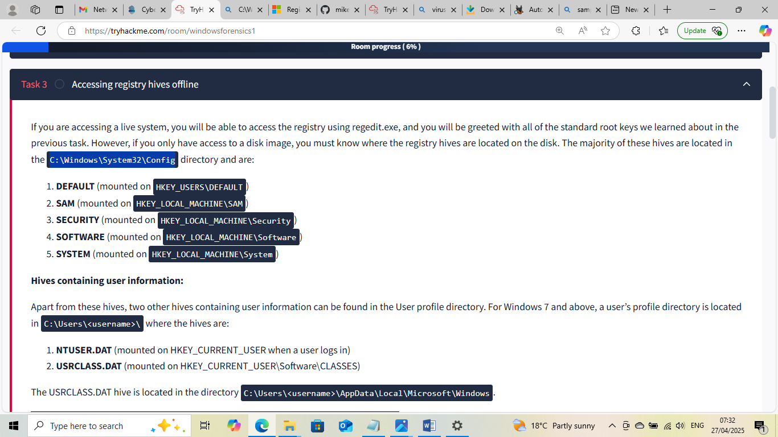

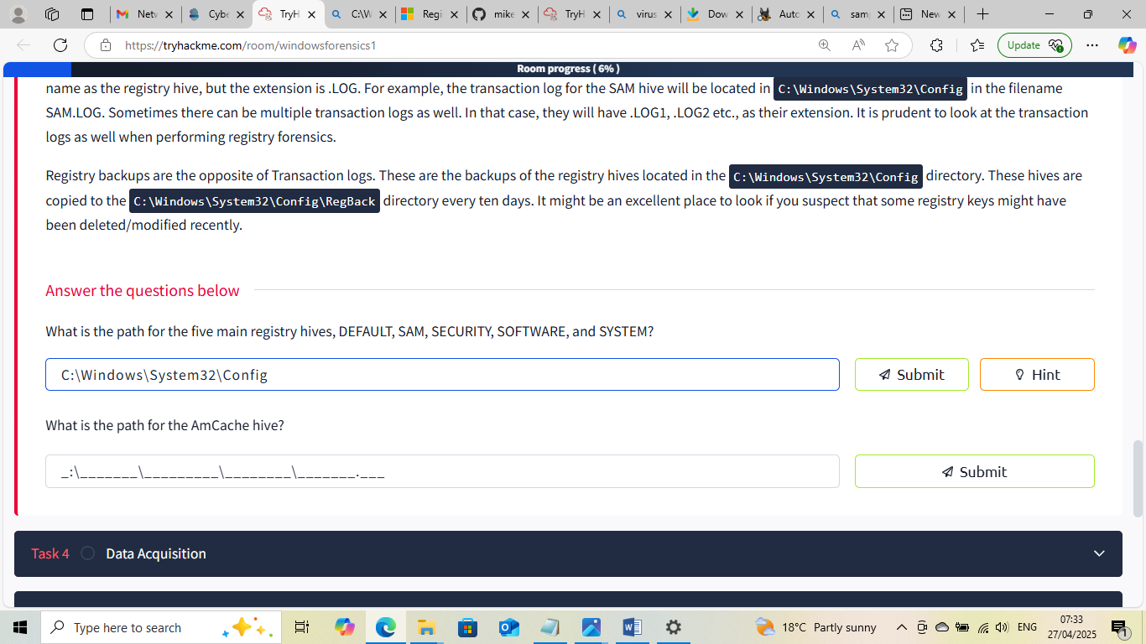
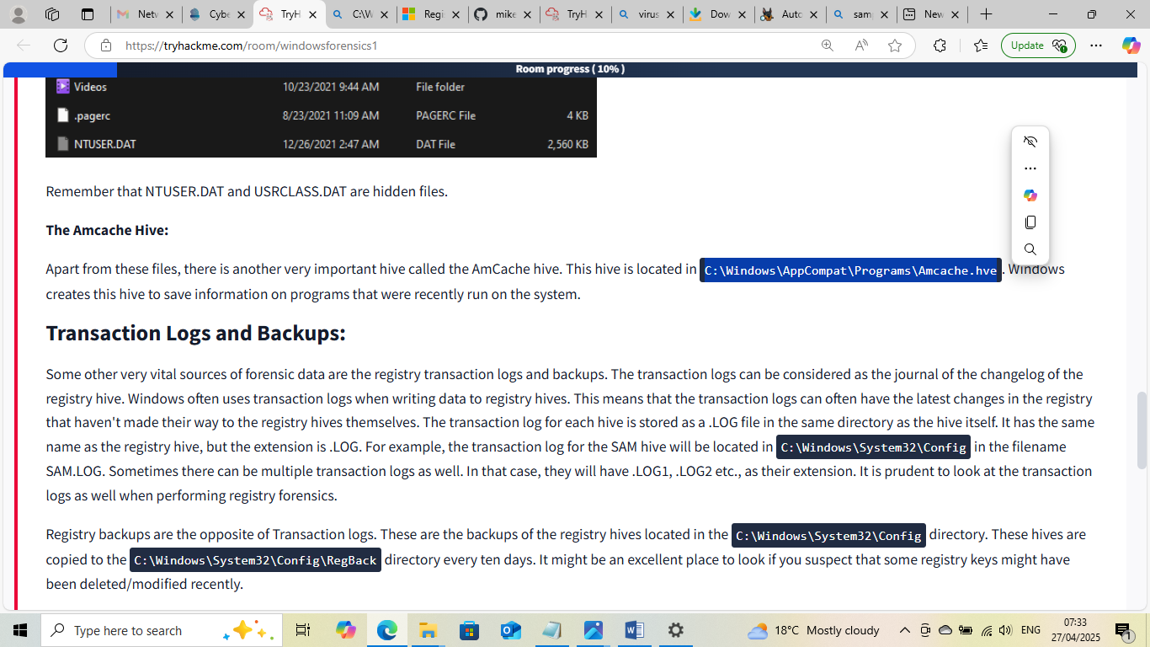

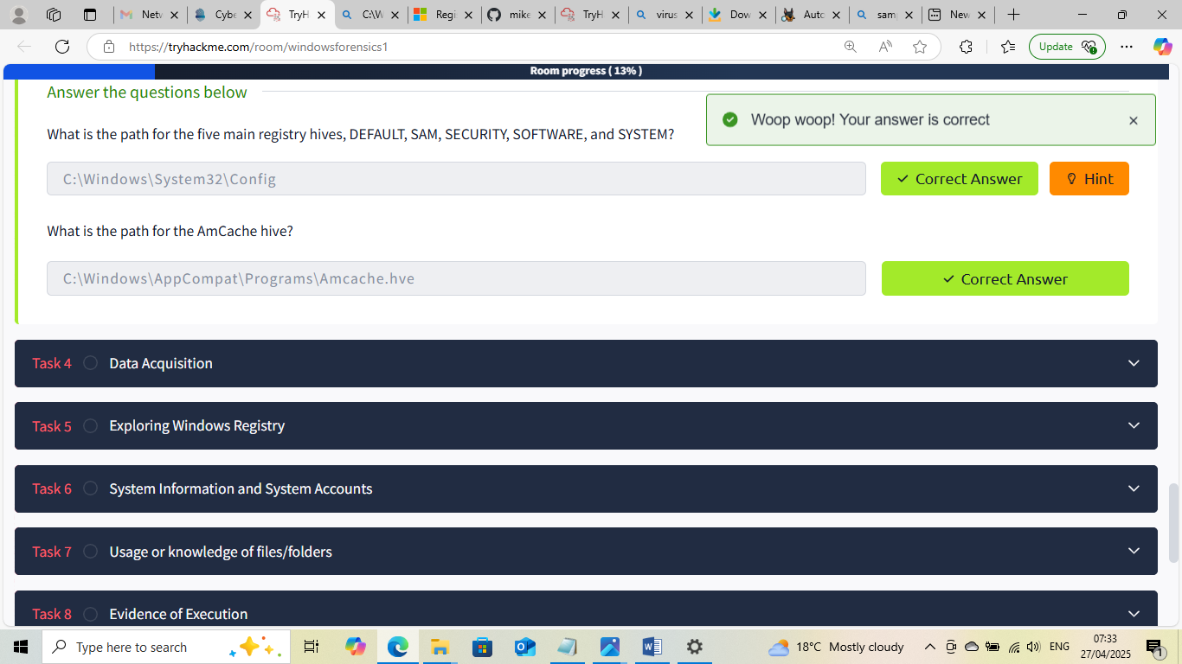

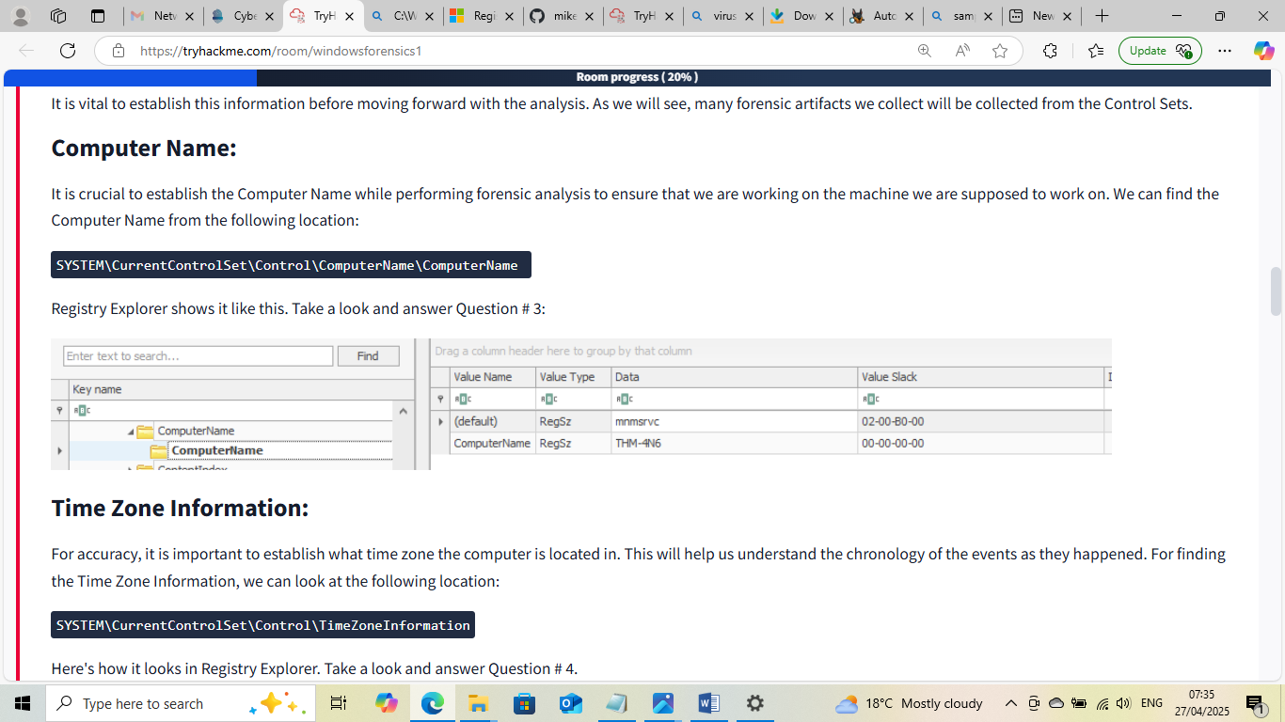

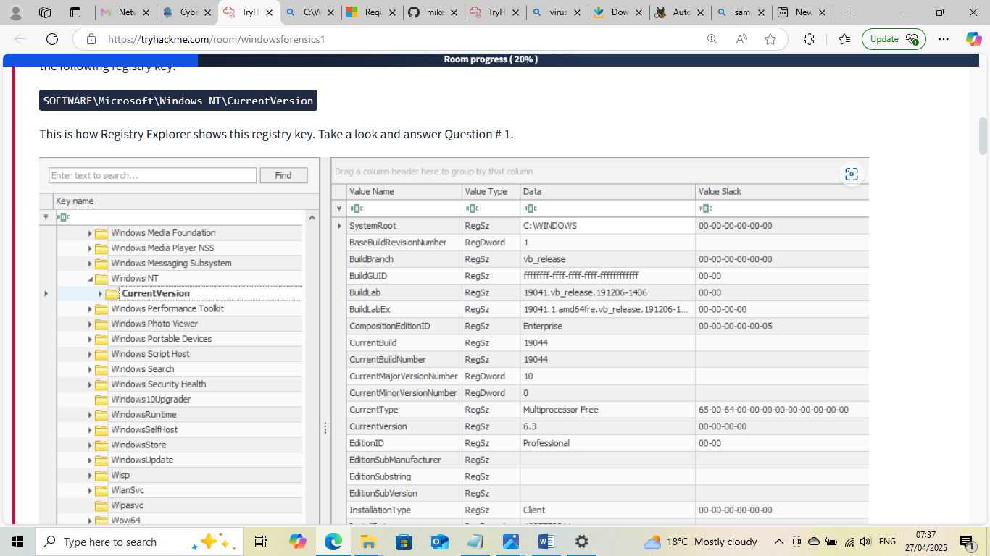

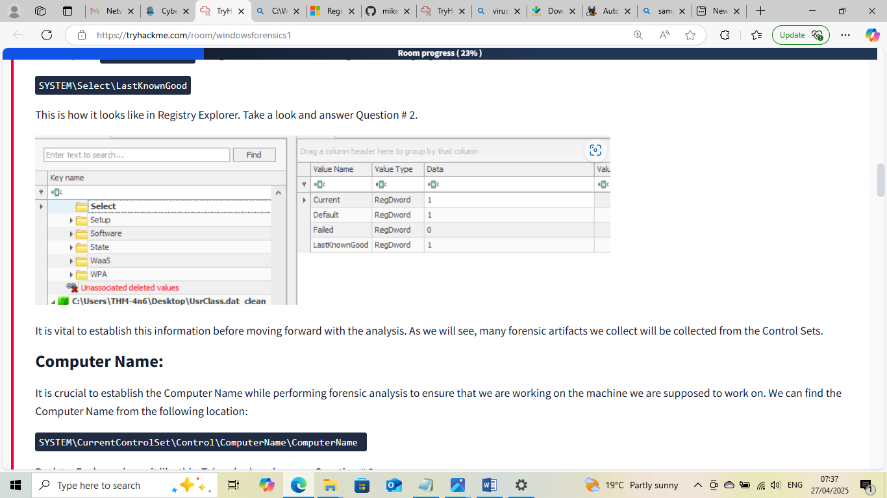

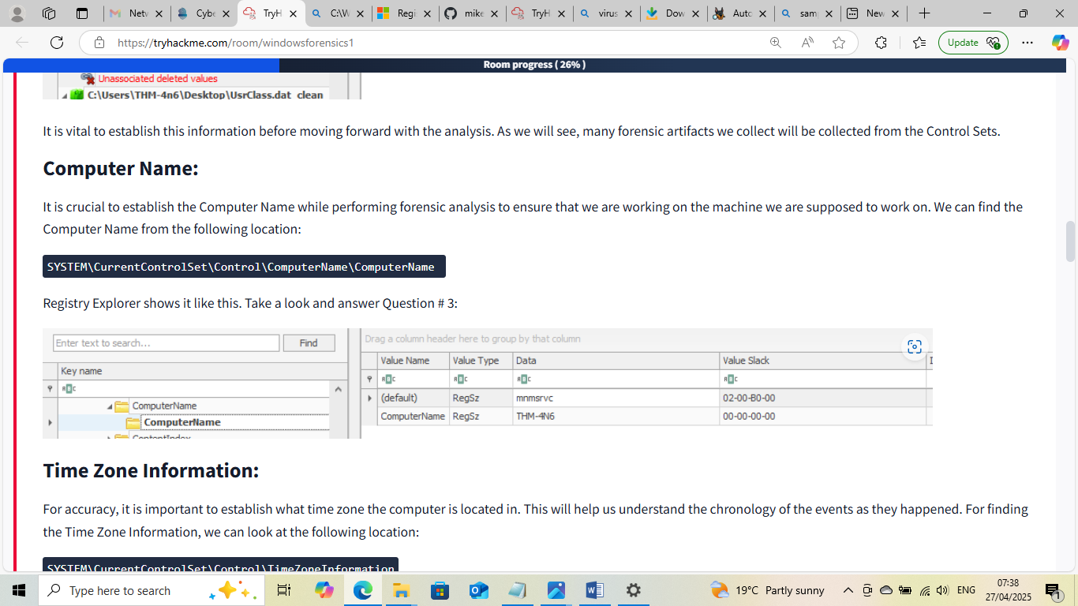

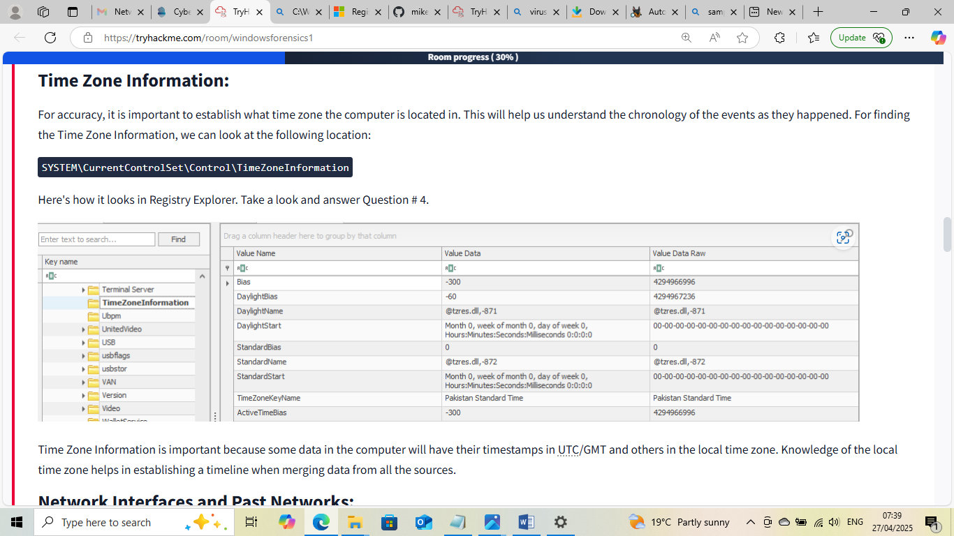


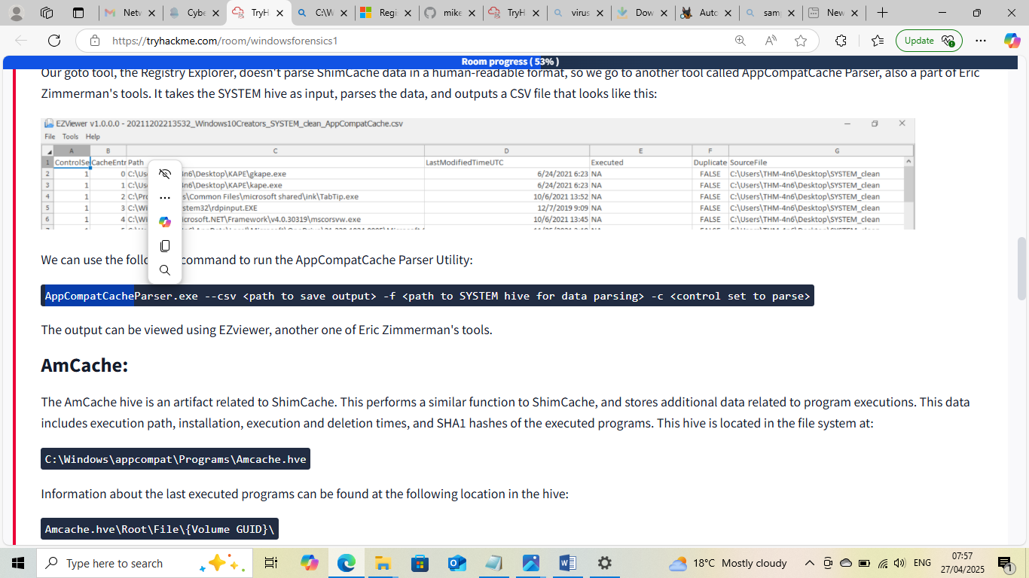

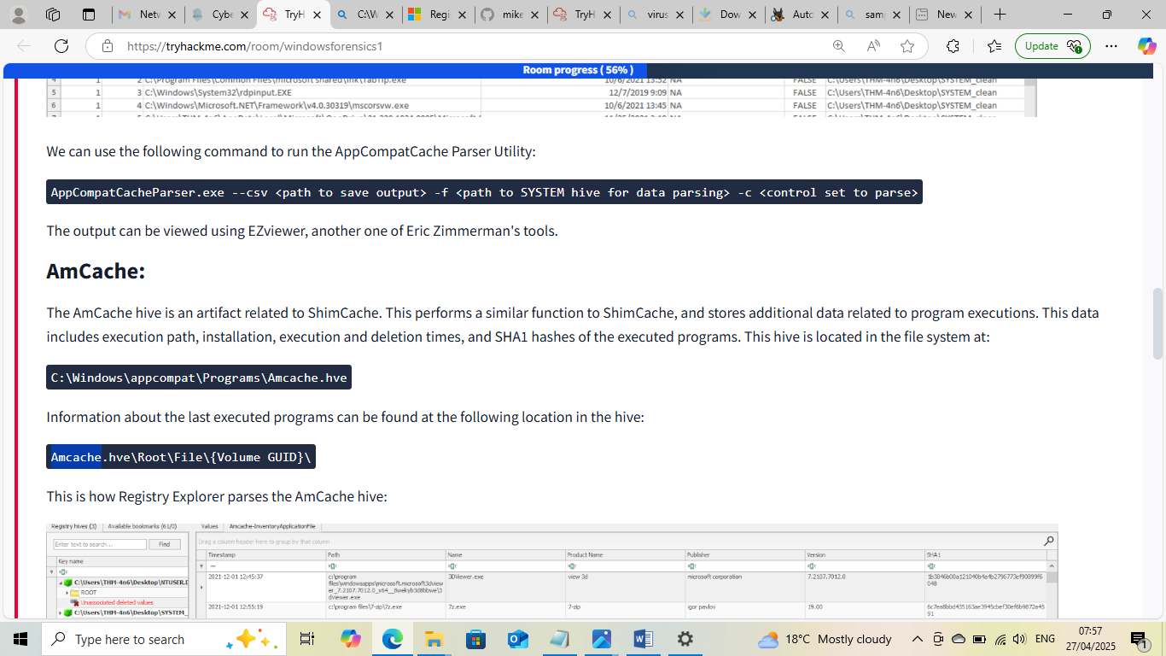






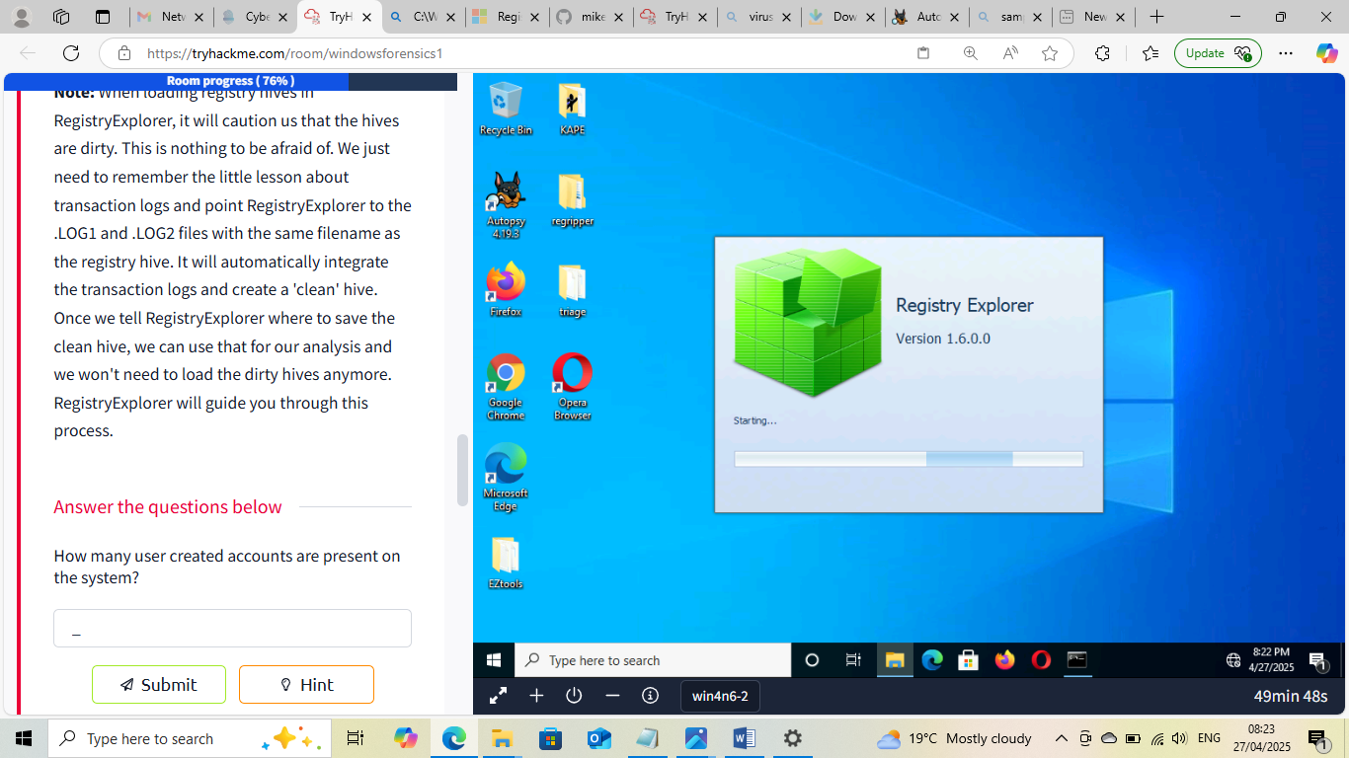

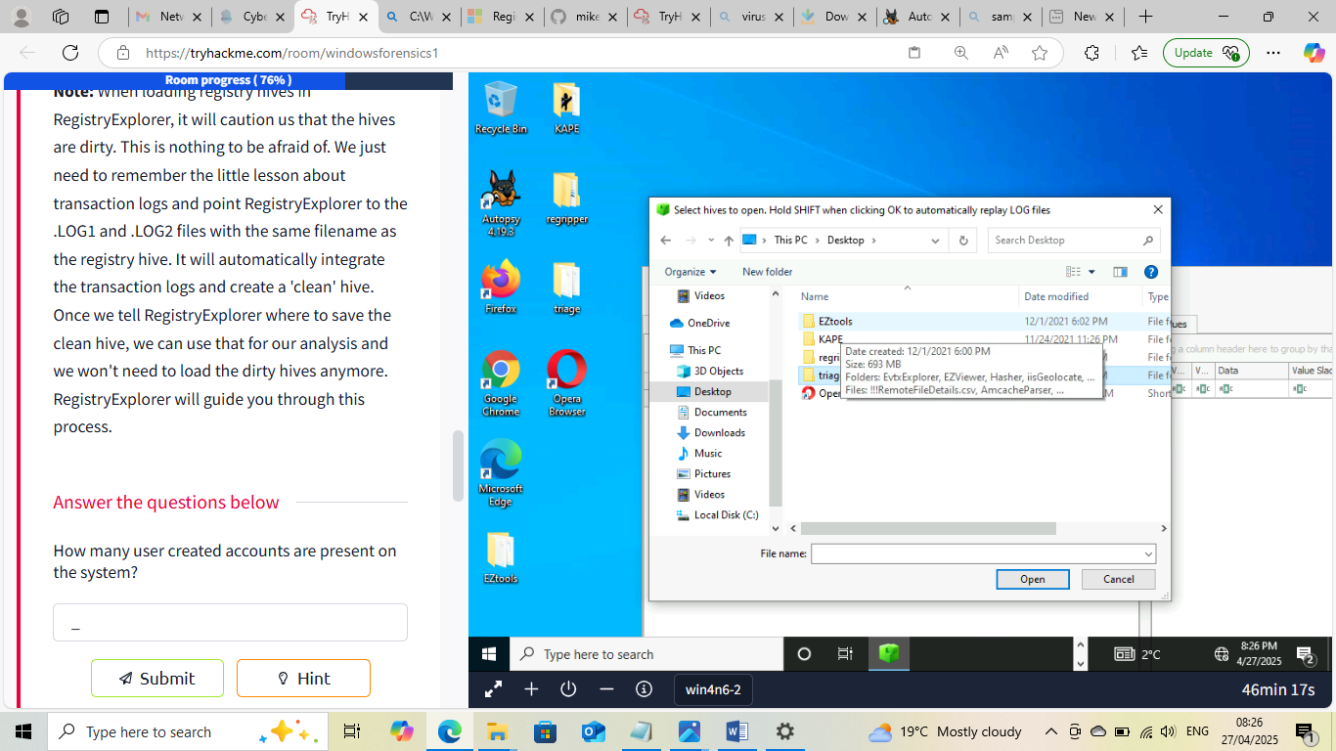

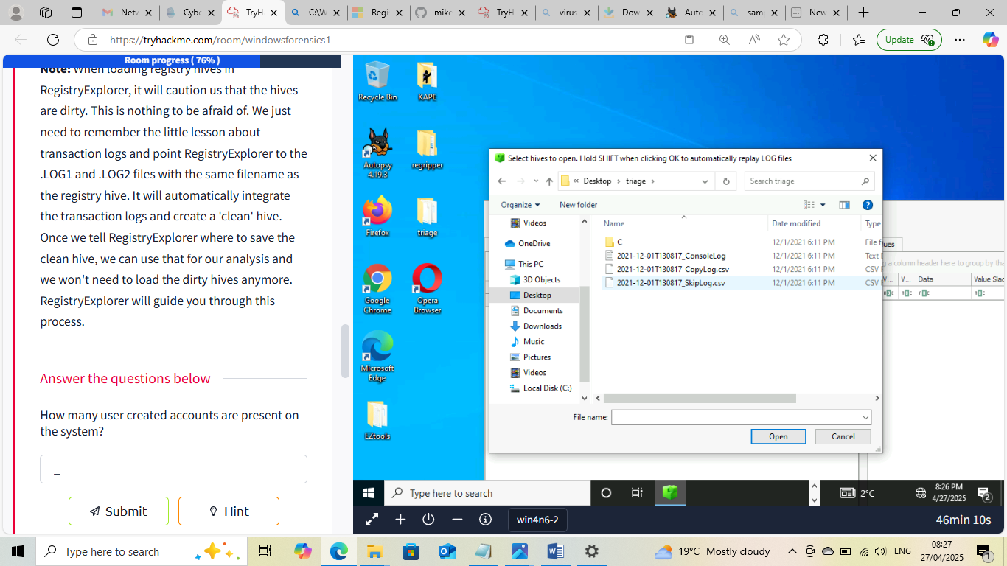

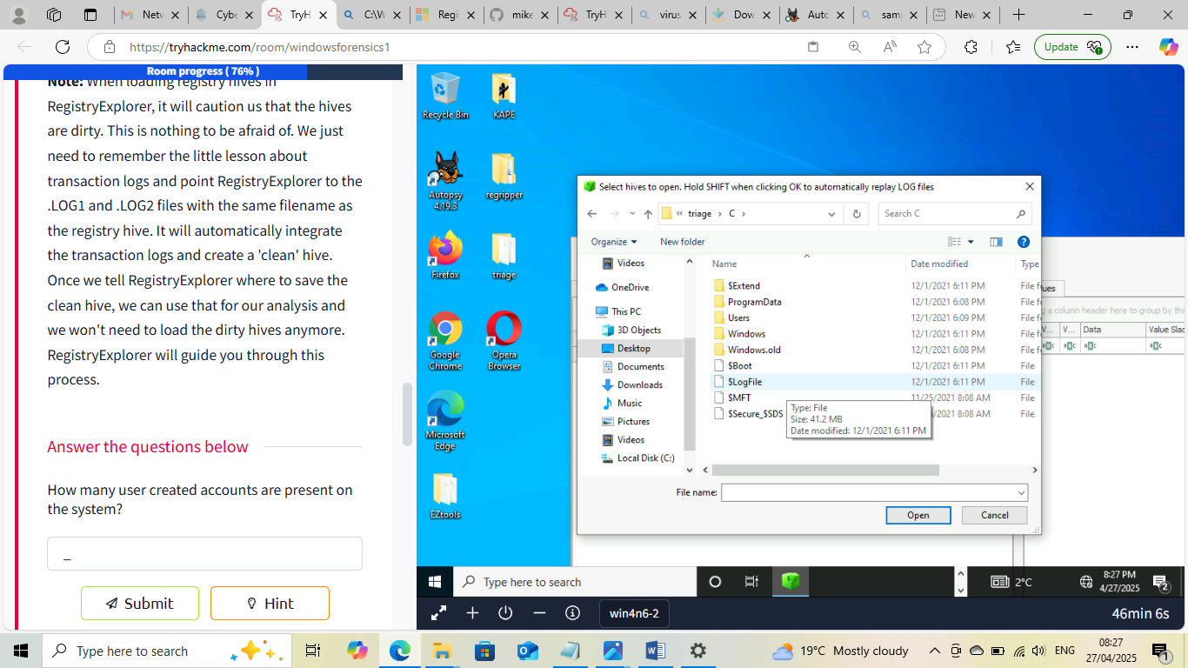

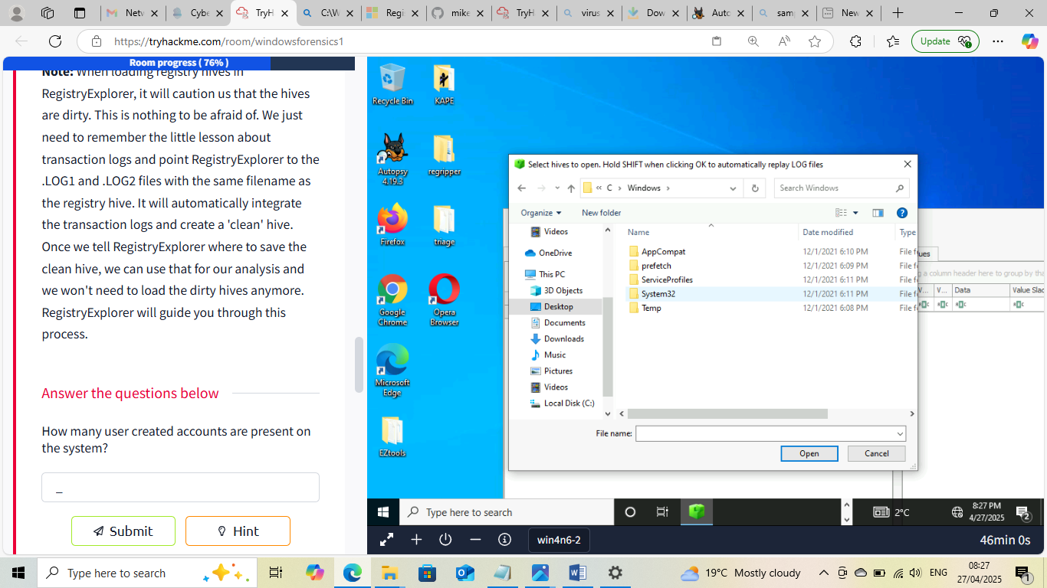
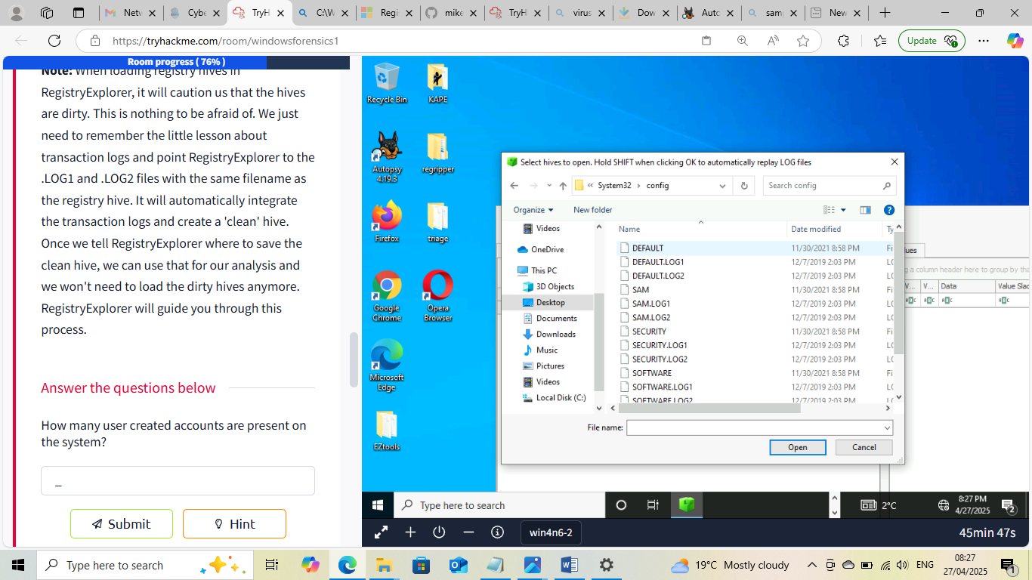

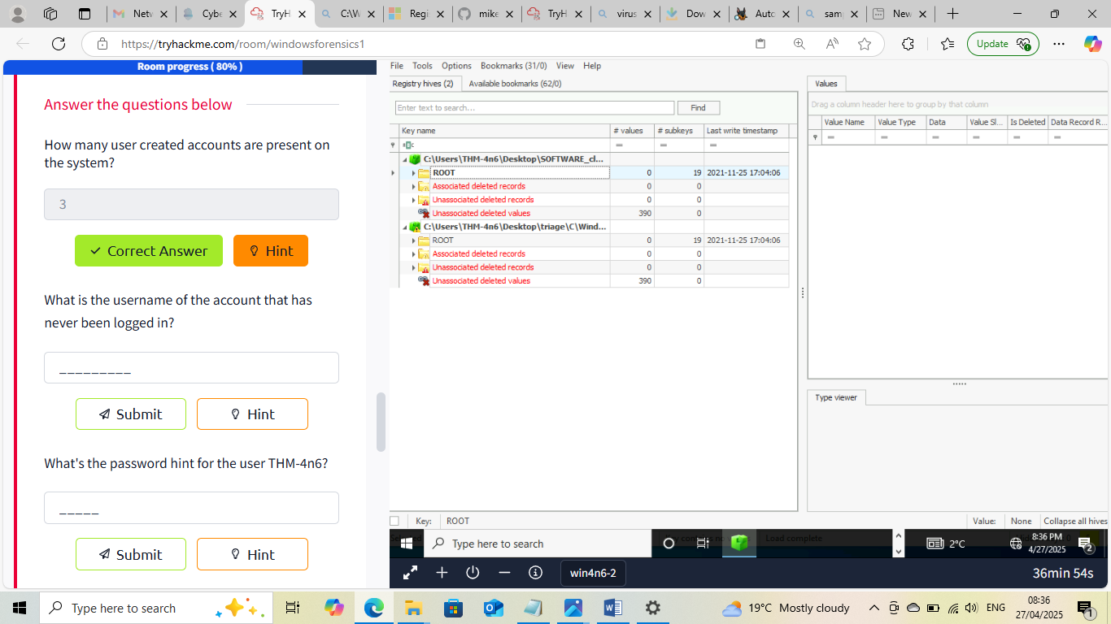

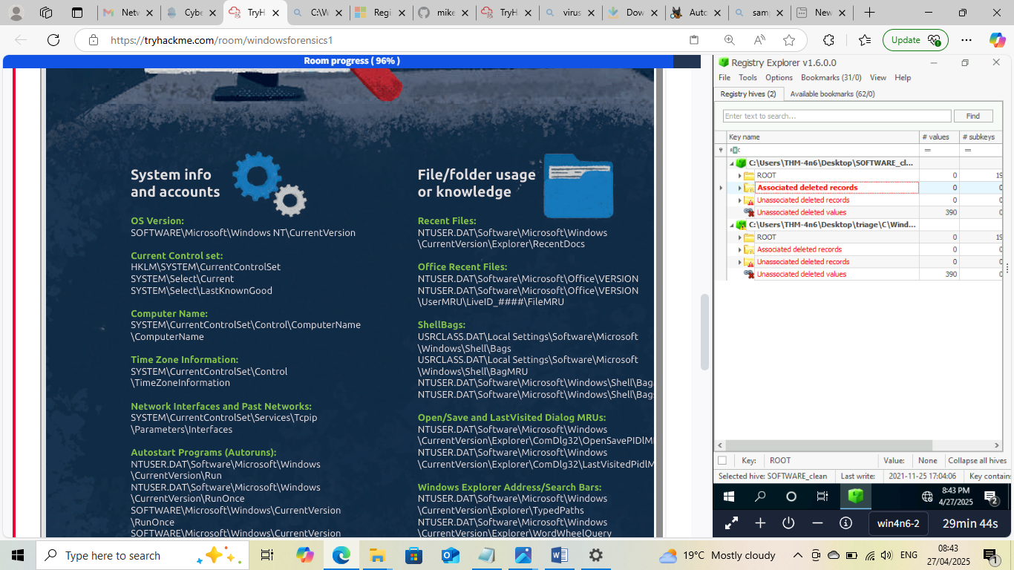




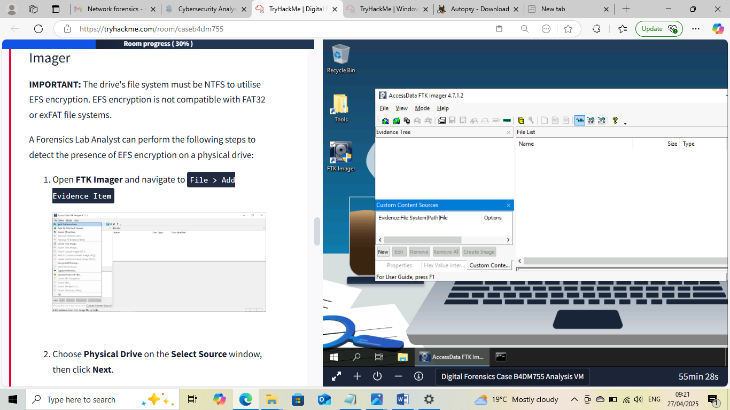

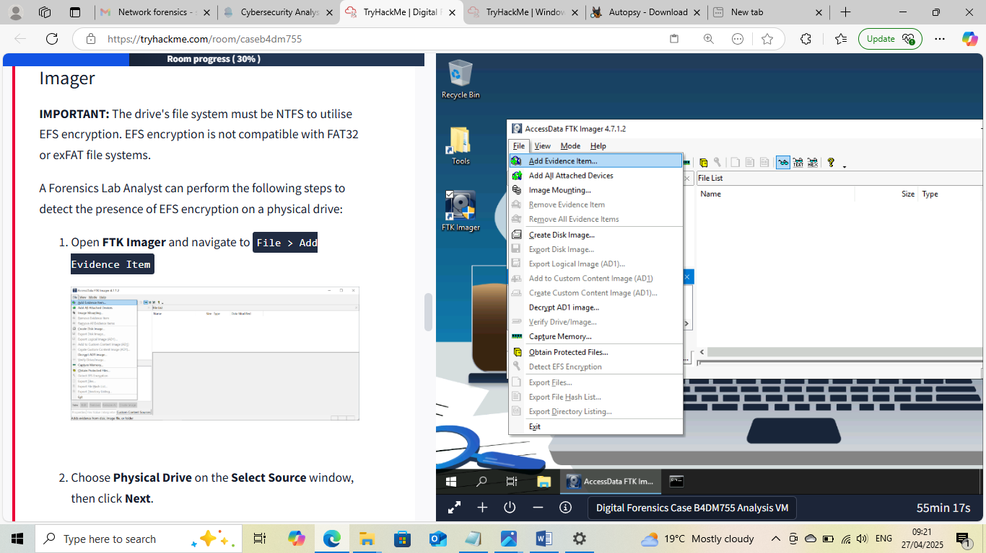

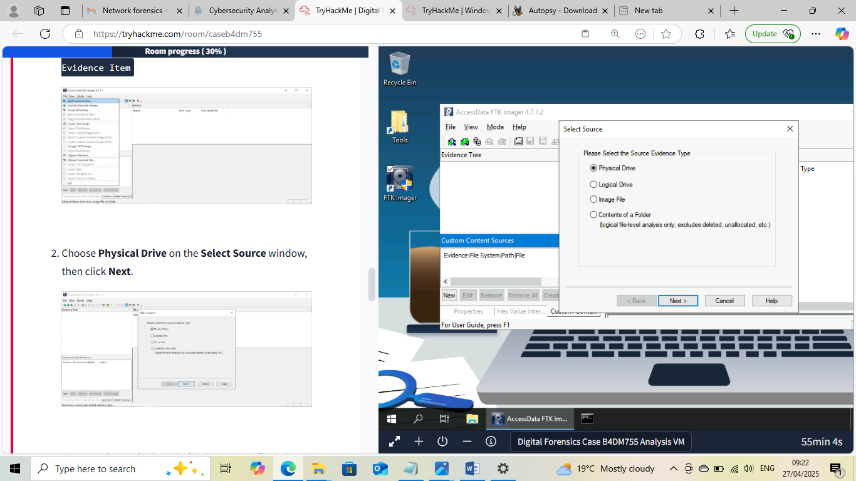

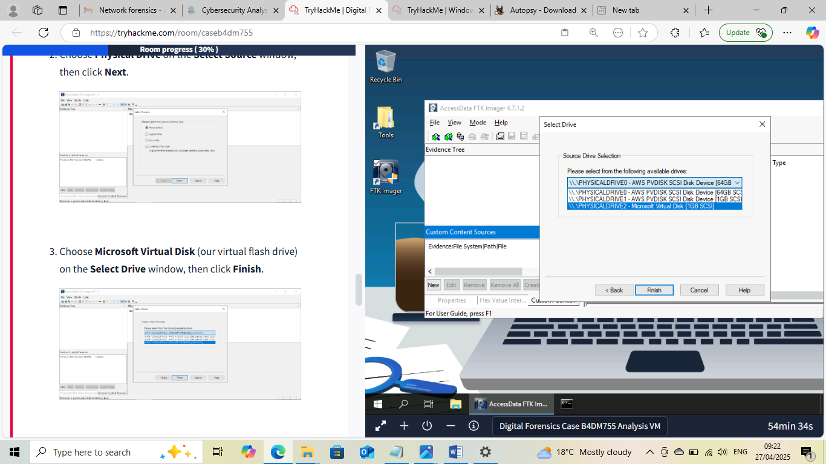

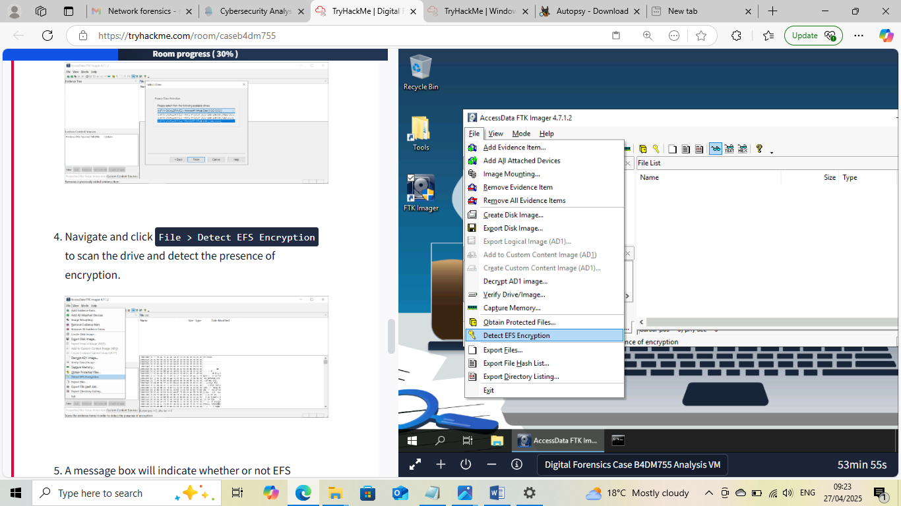

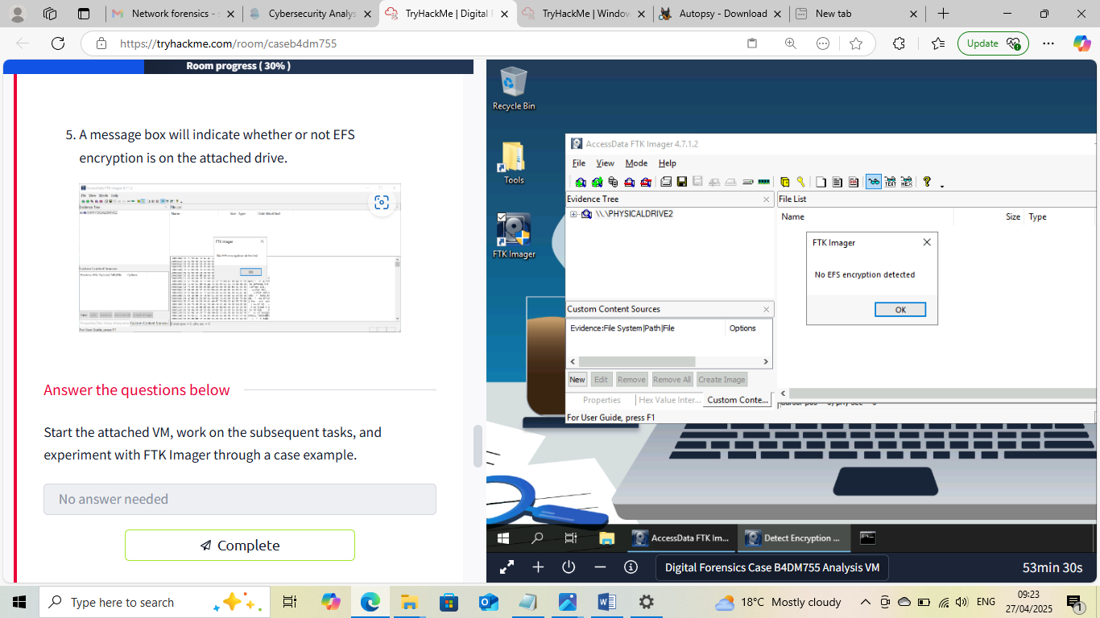

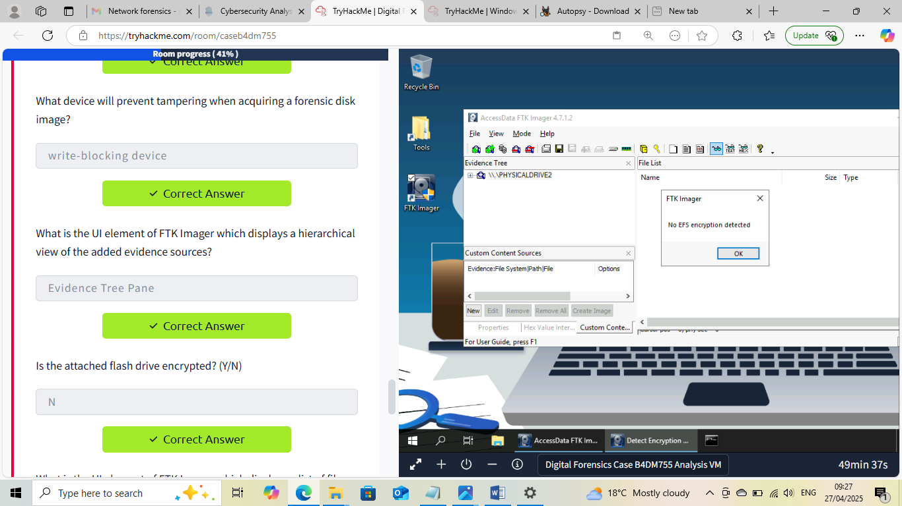
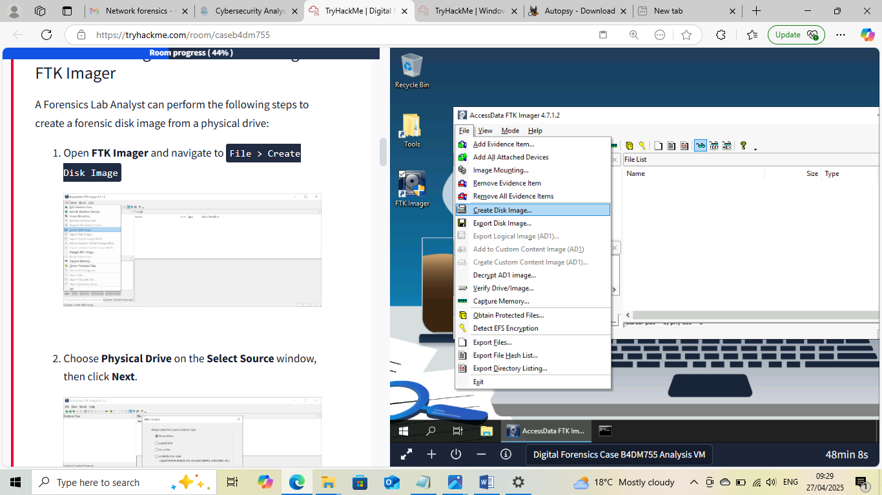

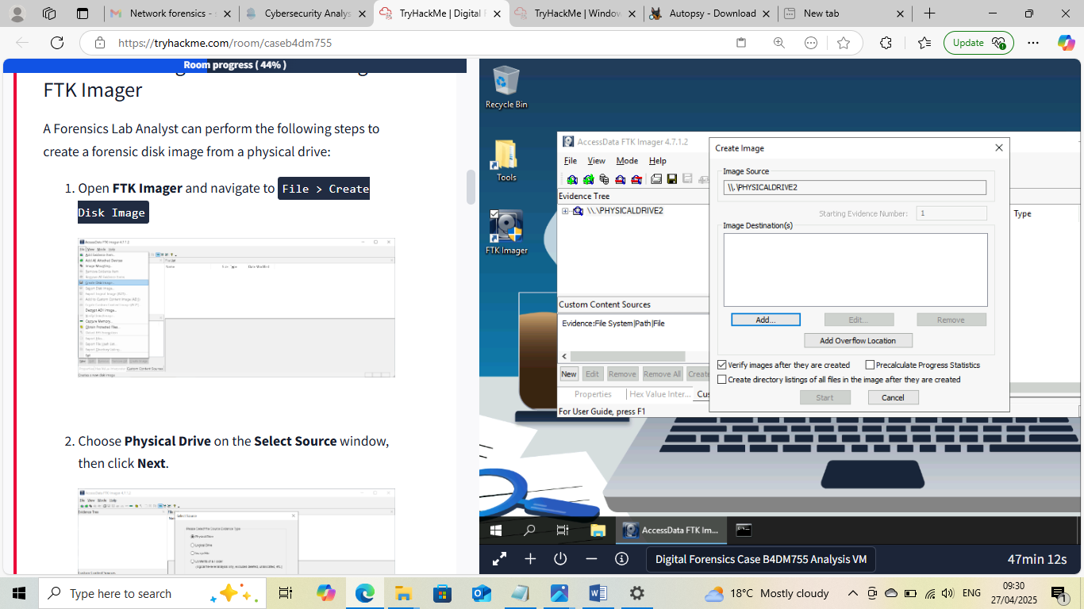

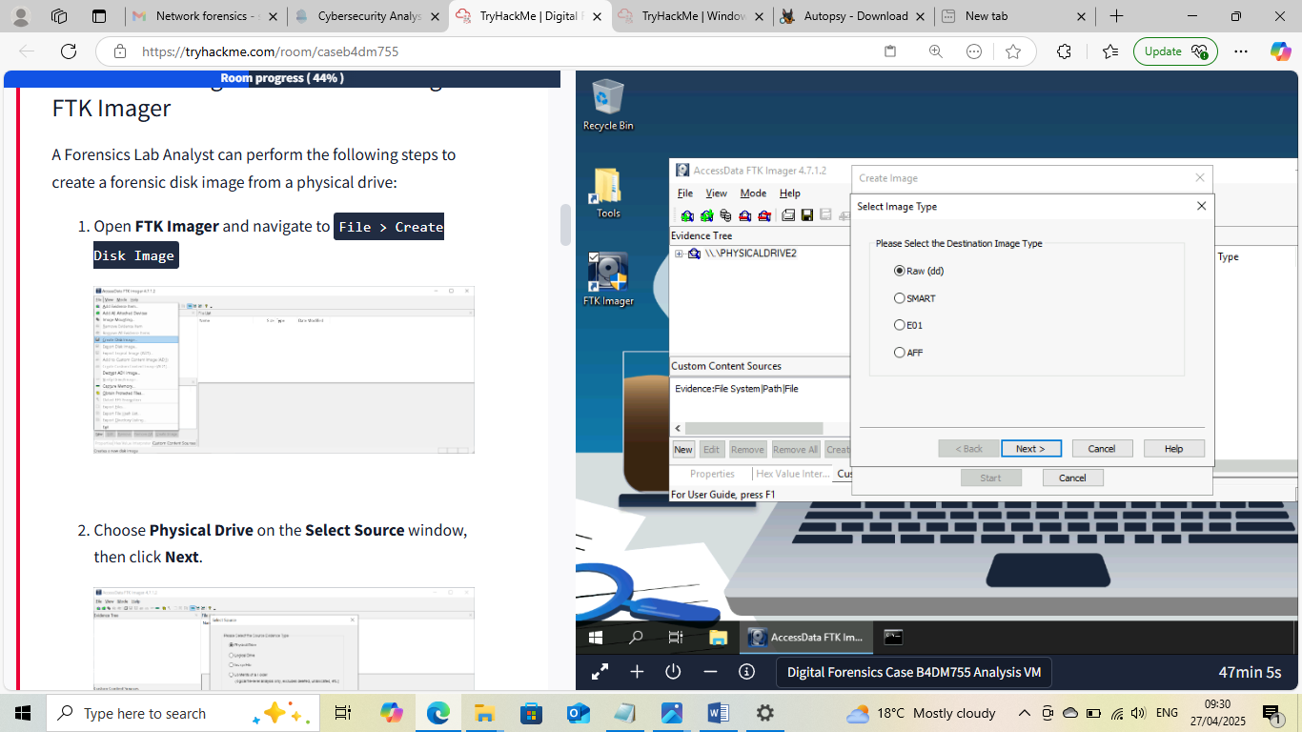

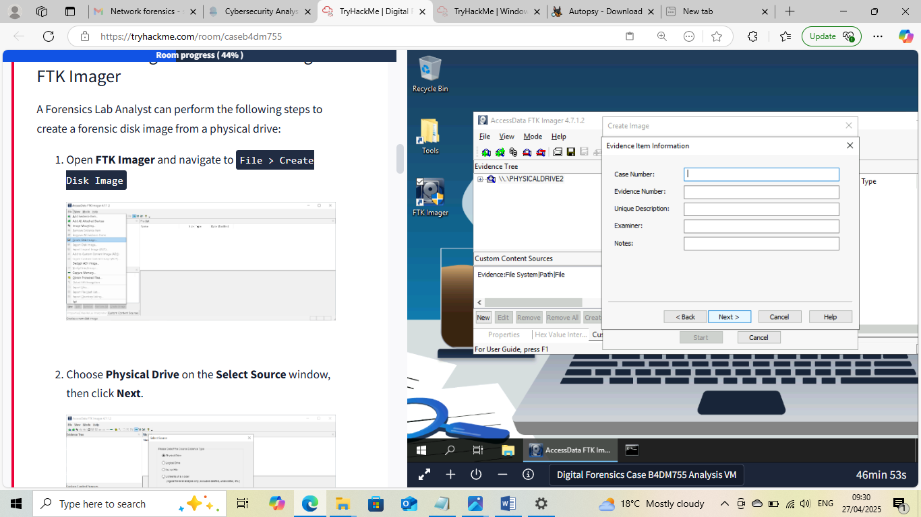

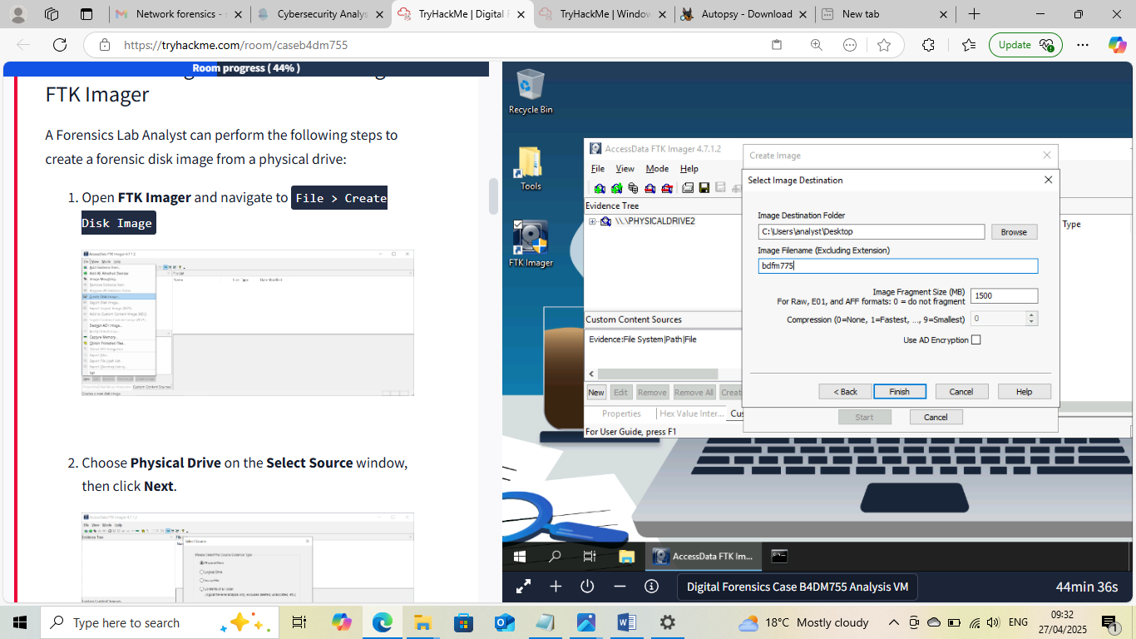

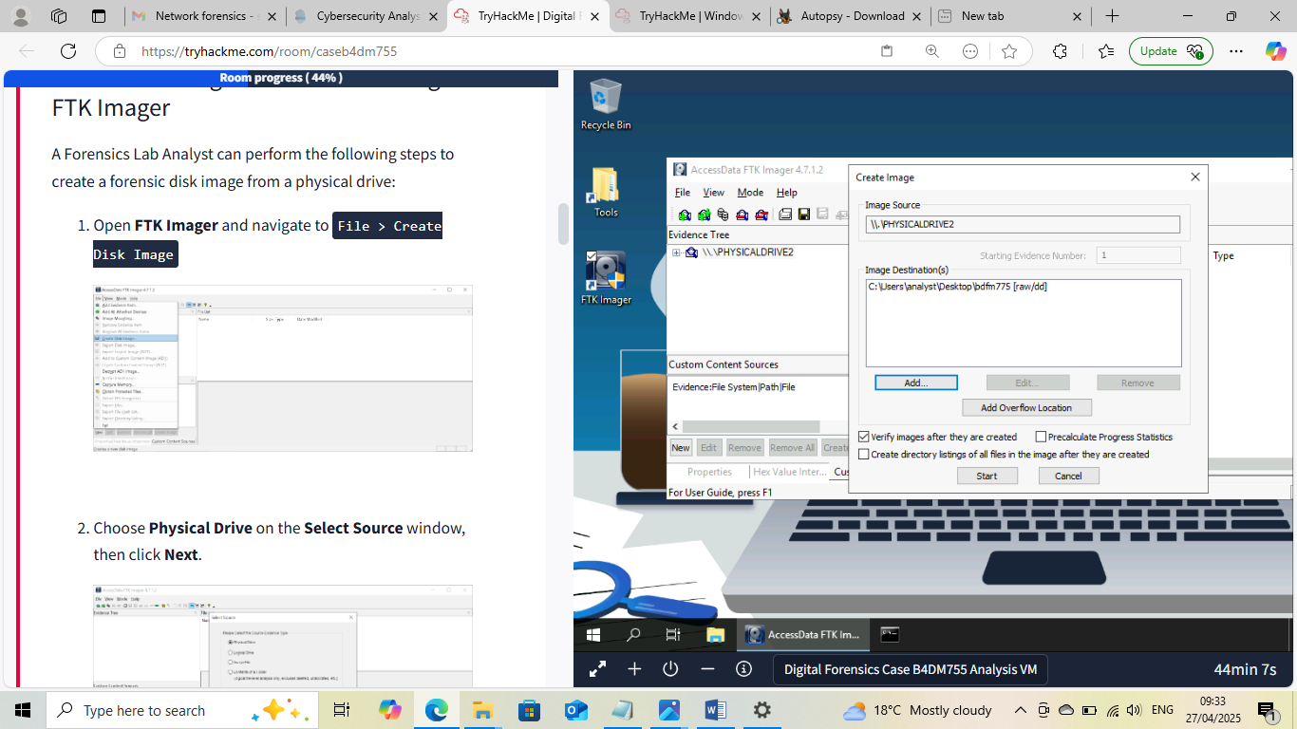
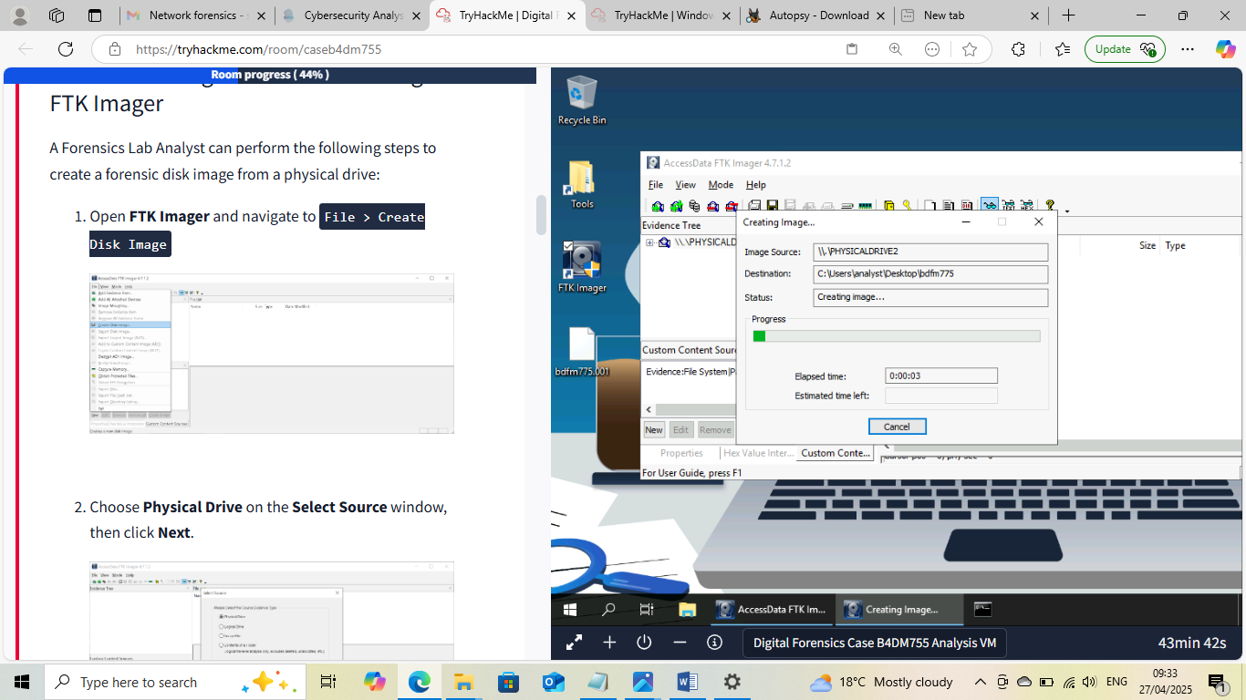

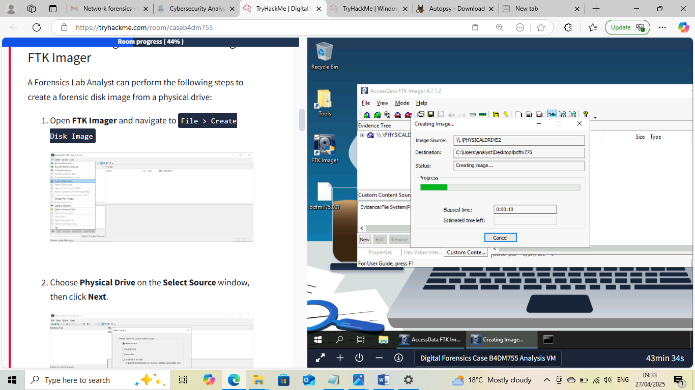

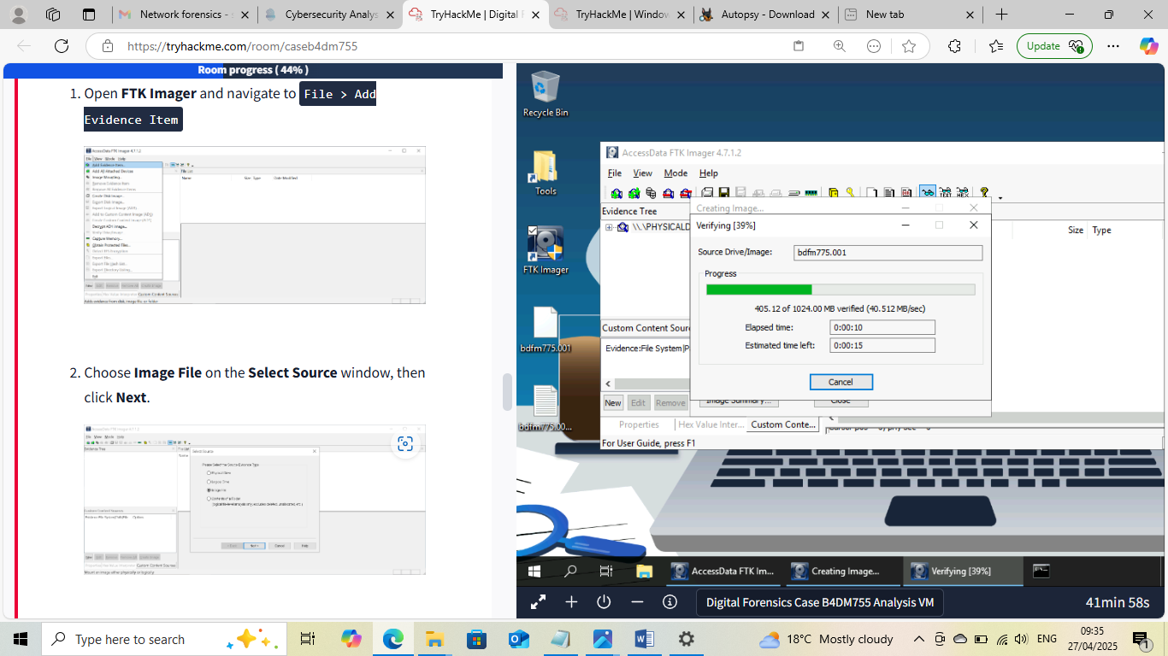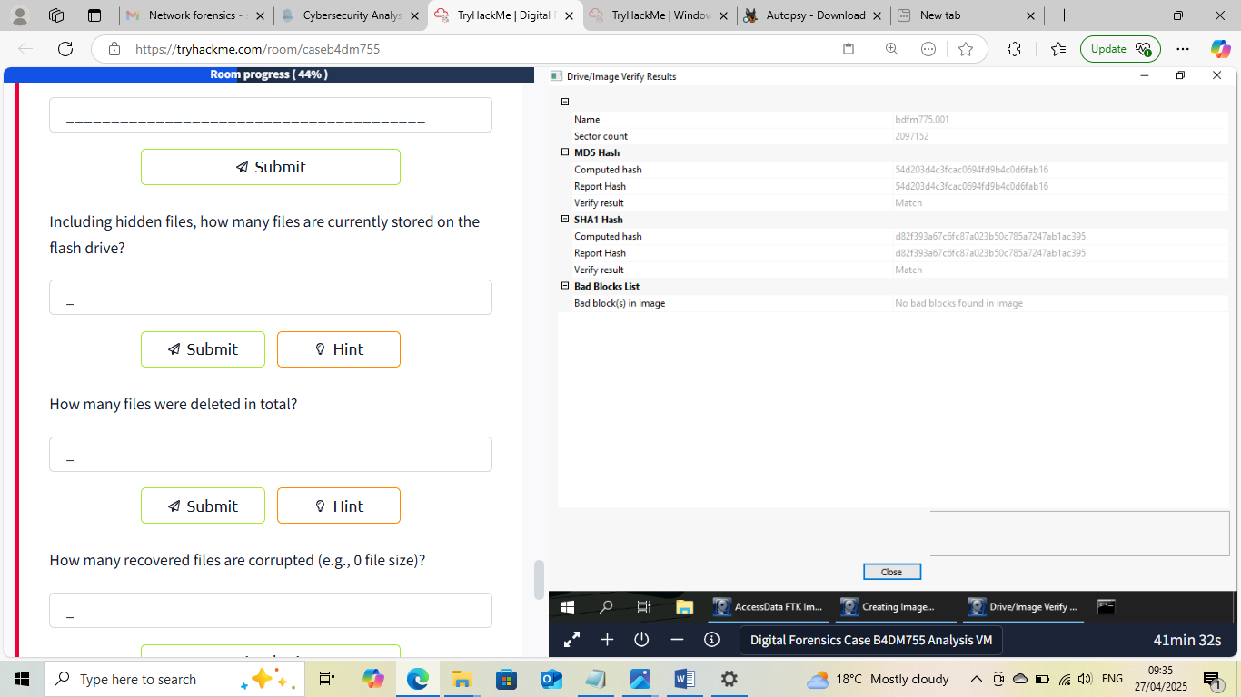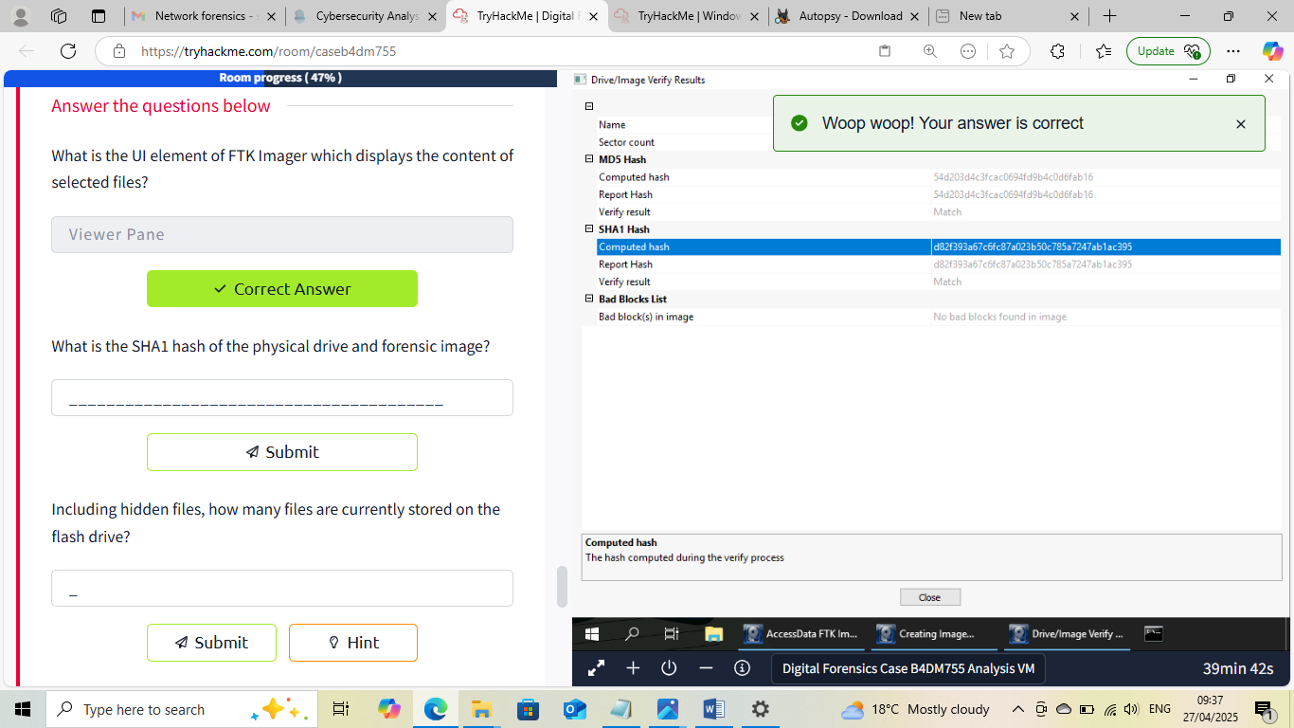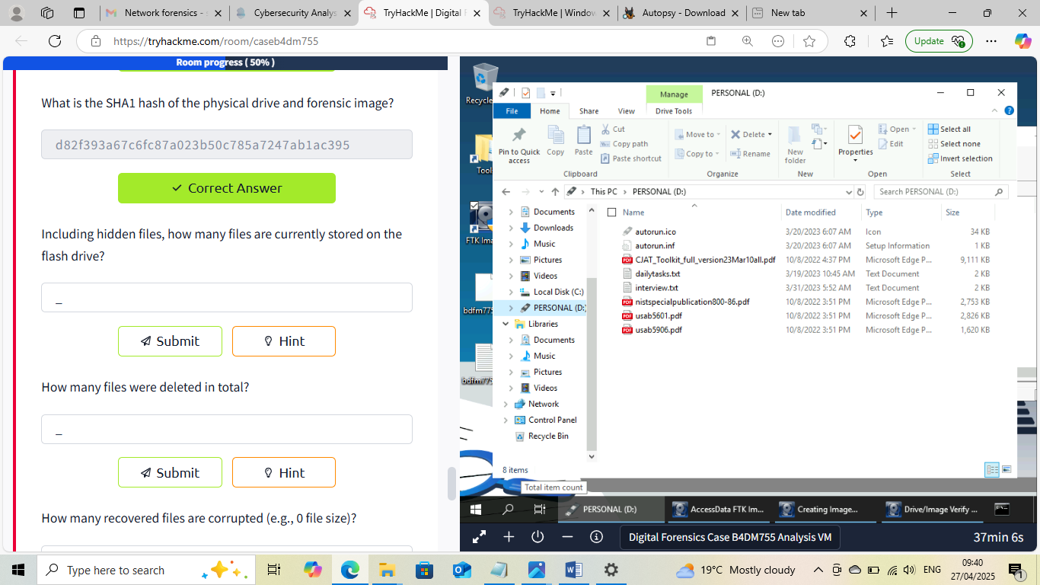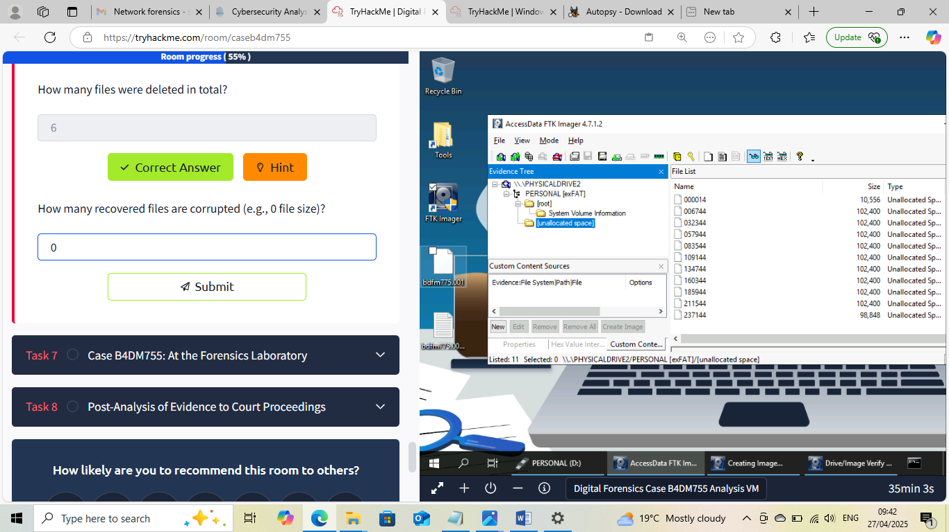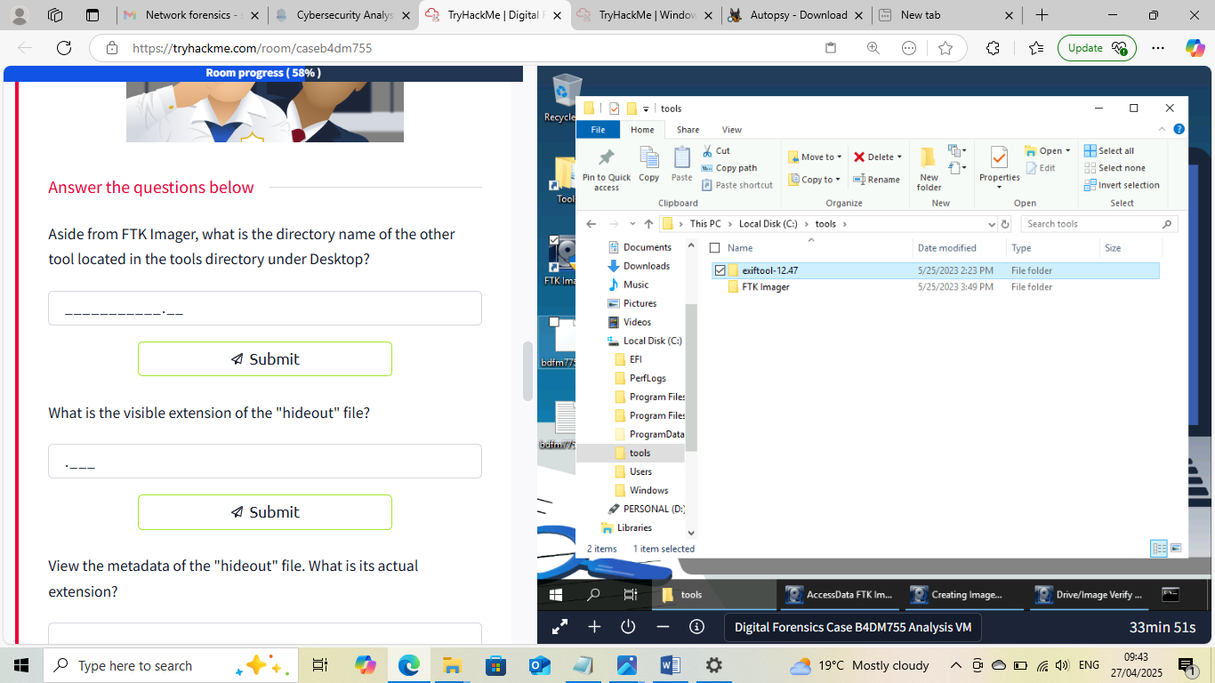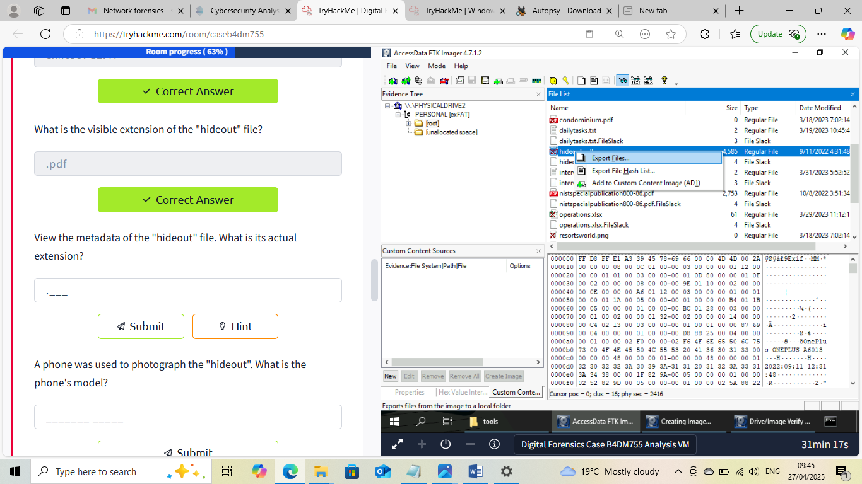


This Internship Task report was developed on [April, 27, 2025]

By:
[ samfelix15@gmail.com ]

